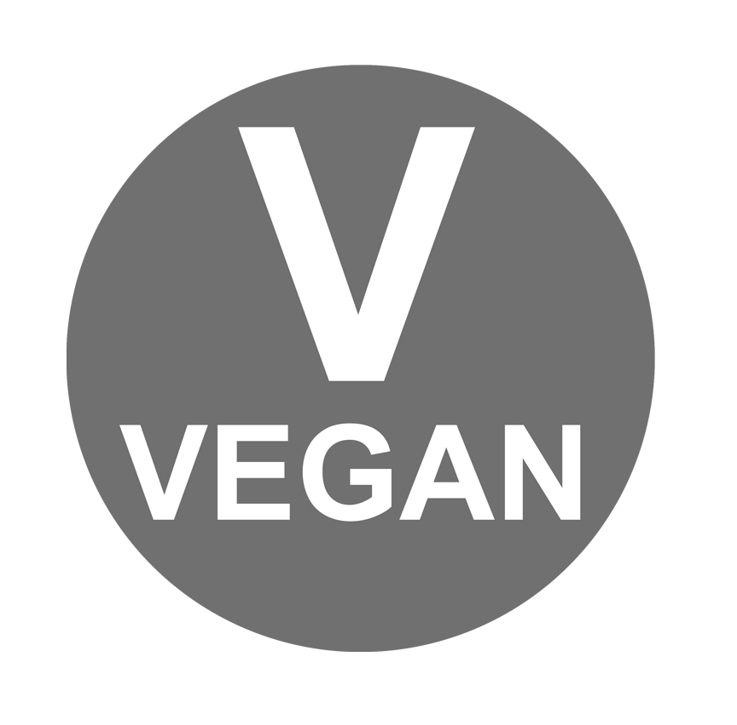
Recommended

Quotes

"It is time to start asking questions about our habits, our ethics, our traditions and of our inhumane civilisation. When we realise they need to change, we have to take action."
Berty Justice - human being

“The meat industry spends hundreds of millions of dollars lying to the public about their product. But no amount of false propaganda can sanitize meat. The facts are absolutely clear: Eating meat is bad for human health, catastrophic for the environment, and a living nightmare for animals.”
Chrissy Hynde - Singer/songwriter of the pretenders

“If slaughterhouses had glass walls, everyone would be vegetarian. We feel better about ourselves and better about the animals knowing we are not contributing to their pain.”
Linda Mcartney

“Thousands of people who say they ‘love animals’ sit down once or twice a day to enjoy the flesh of creatures who have been utterly deprived of everything that could make their lives worth living and who endured the awful suffering and terror of the abattoirs.”
Dr. Jane Goodall, PHD
conservationist and primatologist

“Nothing will benefit human health and increase the chances for survival of life as much as the evolution to a vegetarian diet.”
Albert Einstein

Information Websites
www.bertyjustice.co.uk (Has a lerge Veganism section, Recommended, athletes and more)
www.viva.org.uk (Current campaigns, art, food and helpful advice)
www.vegetarian.org.uk (Extensive health Information)
www.vegansociety.com (Vegan community and more information)
www.guidetoveganliving.org.uk (A helpful Vegan society website)
www.runningraw.com (Raw vegan athlete)
www.veganrunners.org.uk (Running club that is open to all abilities, and is all vegan)
www.adappt.org (Gary Yourofsky and his campaigns)
www.towerhillstables.com (Fiona Oakes’ animal sanctuary)
www.ble.at (A solely Vegan facebook)
www.forksoverknives.com (Health information and recipes)
www.veggiewines.co.uk (A large list of Vegan and Vegetarian friendly alcohol)
www.music.vegan.fr (Large list of Vegan bands)
www.organicathlete.org (An athletic membership community for Vegetarians and Vegans)

Recipes
www.vegetarianrecipeclub.org.uk (hundreds of Vegan recipes)
www.veganvillage.co.uk (Lots of exciting recipes and lists of Vegan retailers)
www.ohsheglows.com (Vegan recipe blog and vegan lifestyle information)
www.lindamcartney.com (Vegan and vegetarian recipes)
www.transitionplymouth.com/food (Lots of recipes and ideas for using local foods)
www.theppk.com (Vegan cooking and baking)

Free Videos Online

Youtube – Search – ‘The waking up process’ - Berty Justice’s channel.

Youtube – Search – ‘Why Vegan? by EVOLVE! Campaigns’ - A short, but informative video.
Youtube – Search - ‘Nathan Runkle, mercy for animals: talks at google’ - Analyses how we treat animals.
Youtube – Search - ‘Best speech you will ever hear, Gary Yourofsky’ - A must watch speech.
Youtube – Search - ‘vivaorg’ - Viva animal charities channel.

Youtube – Search – ‘Melanie Joy - Carnism: The Psychology of Eating Meat’ - Insightful and fascinating.
Youtube – Search - ‘Slaugherhouse: the task of blood’ - A documentary inside a UK slaugherhouse.
Vimeo.com – Search - “Making the connection” - The many reasons to go vegan, by the Vegan society.
Vimeo.com – Search – 'Body Harvest - Arthur Caurty’ – Explores our attitudes towards animals.
www.meatthetruth.nl/en - Meat the Truth’ – Environmental documentary.
www.Earthlings.com - ‘Earthlings’ – Inside the meat and animal industries.

Books

The World Peace Diet: Eating for Spiritual Health and Social Harmony, by Will Tuttle Ph.D.

Lantern Books (2005)

Finding Ultra: Rejecting Middle Age, Becoming One of the World's Fittest Men, and Discovering Myself, Rich Roll, Three Rivers Press (2013)
The Higher Taste: A Gourmet guide to vegetarian cooking and a karma free diet, Bhaktivedanta Book Trust (28 Feb 2007)
Eating Animals, by Jonathan Safran Foer, Penguin Publishing (2010)

Vegan cupcakes take over the world: 75 Dairy-free recipes for cupcakes that rule, by Isa Chandra Moskowitz & Terry Hope Romero (Paperback - 3 Apr 2008)

Veganomicon: The ultimate vegan Cookbook, by Isa Chandra Moskowitz & Terry Hope Romero (Hardcover - 3 Apr 2008)

Shopping
- Find your closest wholefood shop, and start exploring the many things they have on offer.
- Look for Vegan labeled foods and BUAVA (British Union for the Abolition of Vivisection ) certified.
- Co-op home brand toiletries are not tested on animals.
- www.viva.org.uk – They have a large list of Veggie-friendly businesses
- www.lush.co.uk - Fresh handmade Vegan cosmetics

Eating Out Guides

www.viva.org.uk/resources/classified/places-to-eat - Veggie friendly places to eat and stay.
www.happycow.net/ - Worldwide listings of Vegan places to eat.

Health and Science

Google search – ‘Plant proteins in relation to human protein and amino acid nutrition’ - Vernon R Young and Peter L Pellett’. - This paper explains about protein, and shows that plant-based diets are all we need.
www.PCRM.org - Physicians Committee for Responsible Medicine
www.nutritionfacts.org - Nutrional information from Dr Michael Greger M.D.
www.thechinastudy.com - The information source for the wholefood, plant-based diet movement.
www.vrg.org/nutrition/2009_ADA_position_paper.pdf - Confirms Veggie diets are very healthful.
www.viva.org.uk/going-vegetarian-vegan - Clears up the myths about going veggie.
www.vegetarian.org.uk/factsheets/Protein-vegetarian-vegan.pdf - Also clears up the protein myth.

